Press release:
November news from North Hertfordshire Archaeological Society
The Society is delighted to welcome their next guest speaker, Joe Abrams, the director of recent excavations of Luton’s ancient castles. It may come as a surprise to some of us to know that Luton had even one castle – let alone two. But they belonged to turbulent Medieval times when the town was at the centre of the country’s most significant events. It was the twelfth century period of King Stephen and Matilda, of civil war, and the time known as The Anarchy. Today, one of the castles lies under the University Campus, the other near a branch of Matalan.
Before the recent excavations, details of the Luton castles were part of a largely unknown history. Now, thanks to the co-operation of professional planners, archaeologists and historians, dramatic local details have been revealed. Joe weaves a fascinating story, which includes describing the fates of the castle owners and links to King John and Magna Carta.
Joe Abrams is the Regional Manager for the nationally respected consultants Headland Archaeology. His knowledge of the archaeology of the South and East of England is extensive and he has been involved in a number of large local projects including Woburn Estate, Haverhill Technology Park and Vine Solar Farm, Cambridgeshire. He and his family live in Hitchin.

The meeting will be on Tuesday 17th November at 8.00pm at the Letchworth Free Church Hall, Gernon Road, Letchworth Garden City. Admission: non-members £3, members £2 (http://www.nharchsoc.org/)

For further information please contact:
Gil Burleigh, Tel: 0462 713654
Email: grb@gilburleigh29.plus.com.contact
Or for Joe Abrams http://www.headlandarchaeology.com/about-us/key-people/people/joe-abrams/

LONDON BRIDGE
TRANSPORT
VIEW

STAFFORDSHIRE AREA IMPROVEMENTS, WEST COAST MAINLINE
TRANSPORT
VIEW

VINE FARM SOLAR PV, CAMBRIDGESHIRE
POWER GENERATION/DISTRIBUTION
VIEW
Joe Abrams
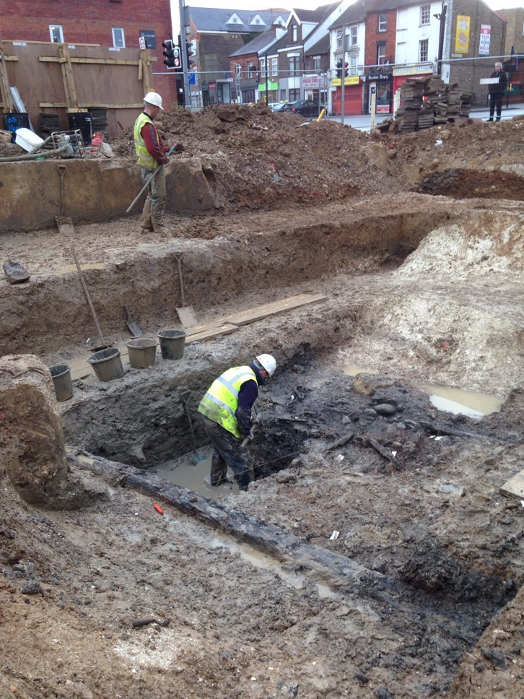
Section through Moat alongside wooden beam, Castle Street

