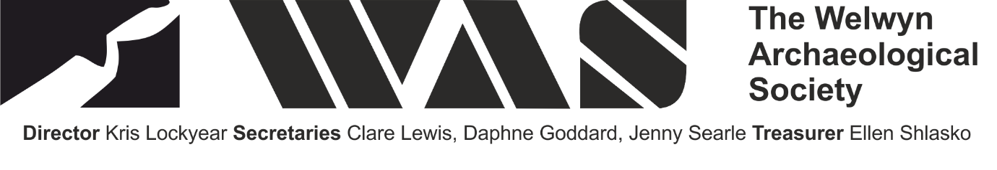
Archaeology in Hertfordshire: Recent Research
26th November 2016
Hitchin Town Hall, Brand Street, 9.10am–4.45pm

9.20 | Andrew Fitzpatrick and Colin Haselgrove | Searching for Julius Caesar
9.50 | Isobel Thompson | New clues to the conquest: how Hertfordshire entered the Roman Empire
10.20 | Michelle Statton | Brooches in Late Iron Age and Roman Hertfordshire
10.50 | tea
11.10 | Emily Esche, Clare Lewis, Kris Lockyear and Tony Rook | Lower Rivers Field
11.40 | Chris Green | Puddingstone querns from Hertfordshire and elsewhere
12.10 | Karin and David Kaye | Roman Ware: A River-Crossing Settlement
12.40 | lunch
1.40 | Keith Fitzpatrick-Matthews | Odd pots and foreigners: forgetting Romanitas, becoming Angelcynn
2.10 | Gil Burleigh | 118+ Tons of History: results from community test pitting and other fieldwork in Pirton
2.40 | Murray Andrews | Coins, commerce, and Christianity: money in late medieval Hertfordshire
3.10 | tea
3.30 | Mike Smith | The medieval manor of Wheathampstead
4.00 | Kris Lockyear and Ellen Shlasko | Surveying Verulamium

Tickets are £15 (£12 for WAS members) which includes morning and afternoon tea, but not lunch. Please send a cheque payable to the Welwyn Archaeological Society with a stamped addressed envelope to Kris Lockyear, 3 Lamer Park, Lamer Lane, Wheathampstead, Herts AL4 8RJ.
There will be tables available for local archaeological or historical societies to have small displays and/or sell publications. We only ask that those manning the stalls have tickets to the conference. Please email Kris on noviodunum@hotmail.com.

